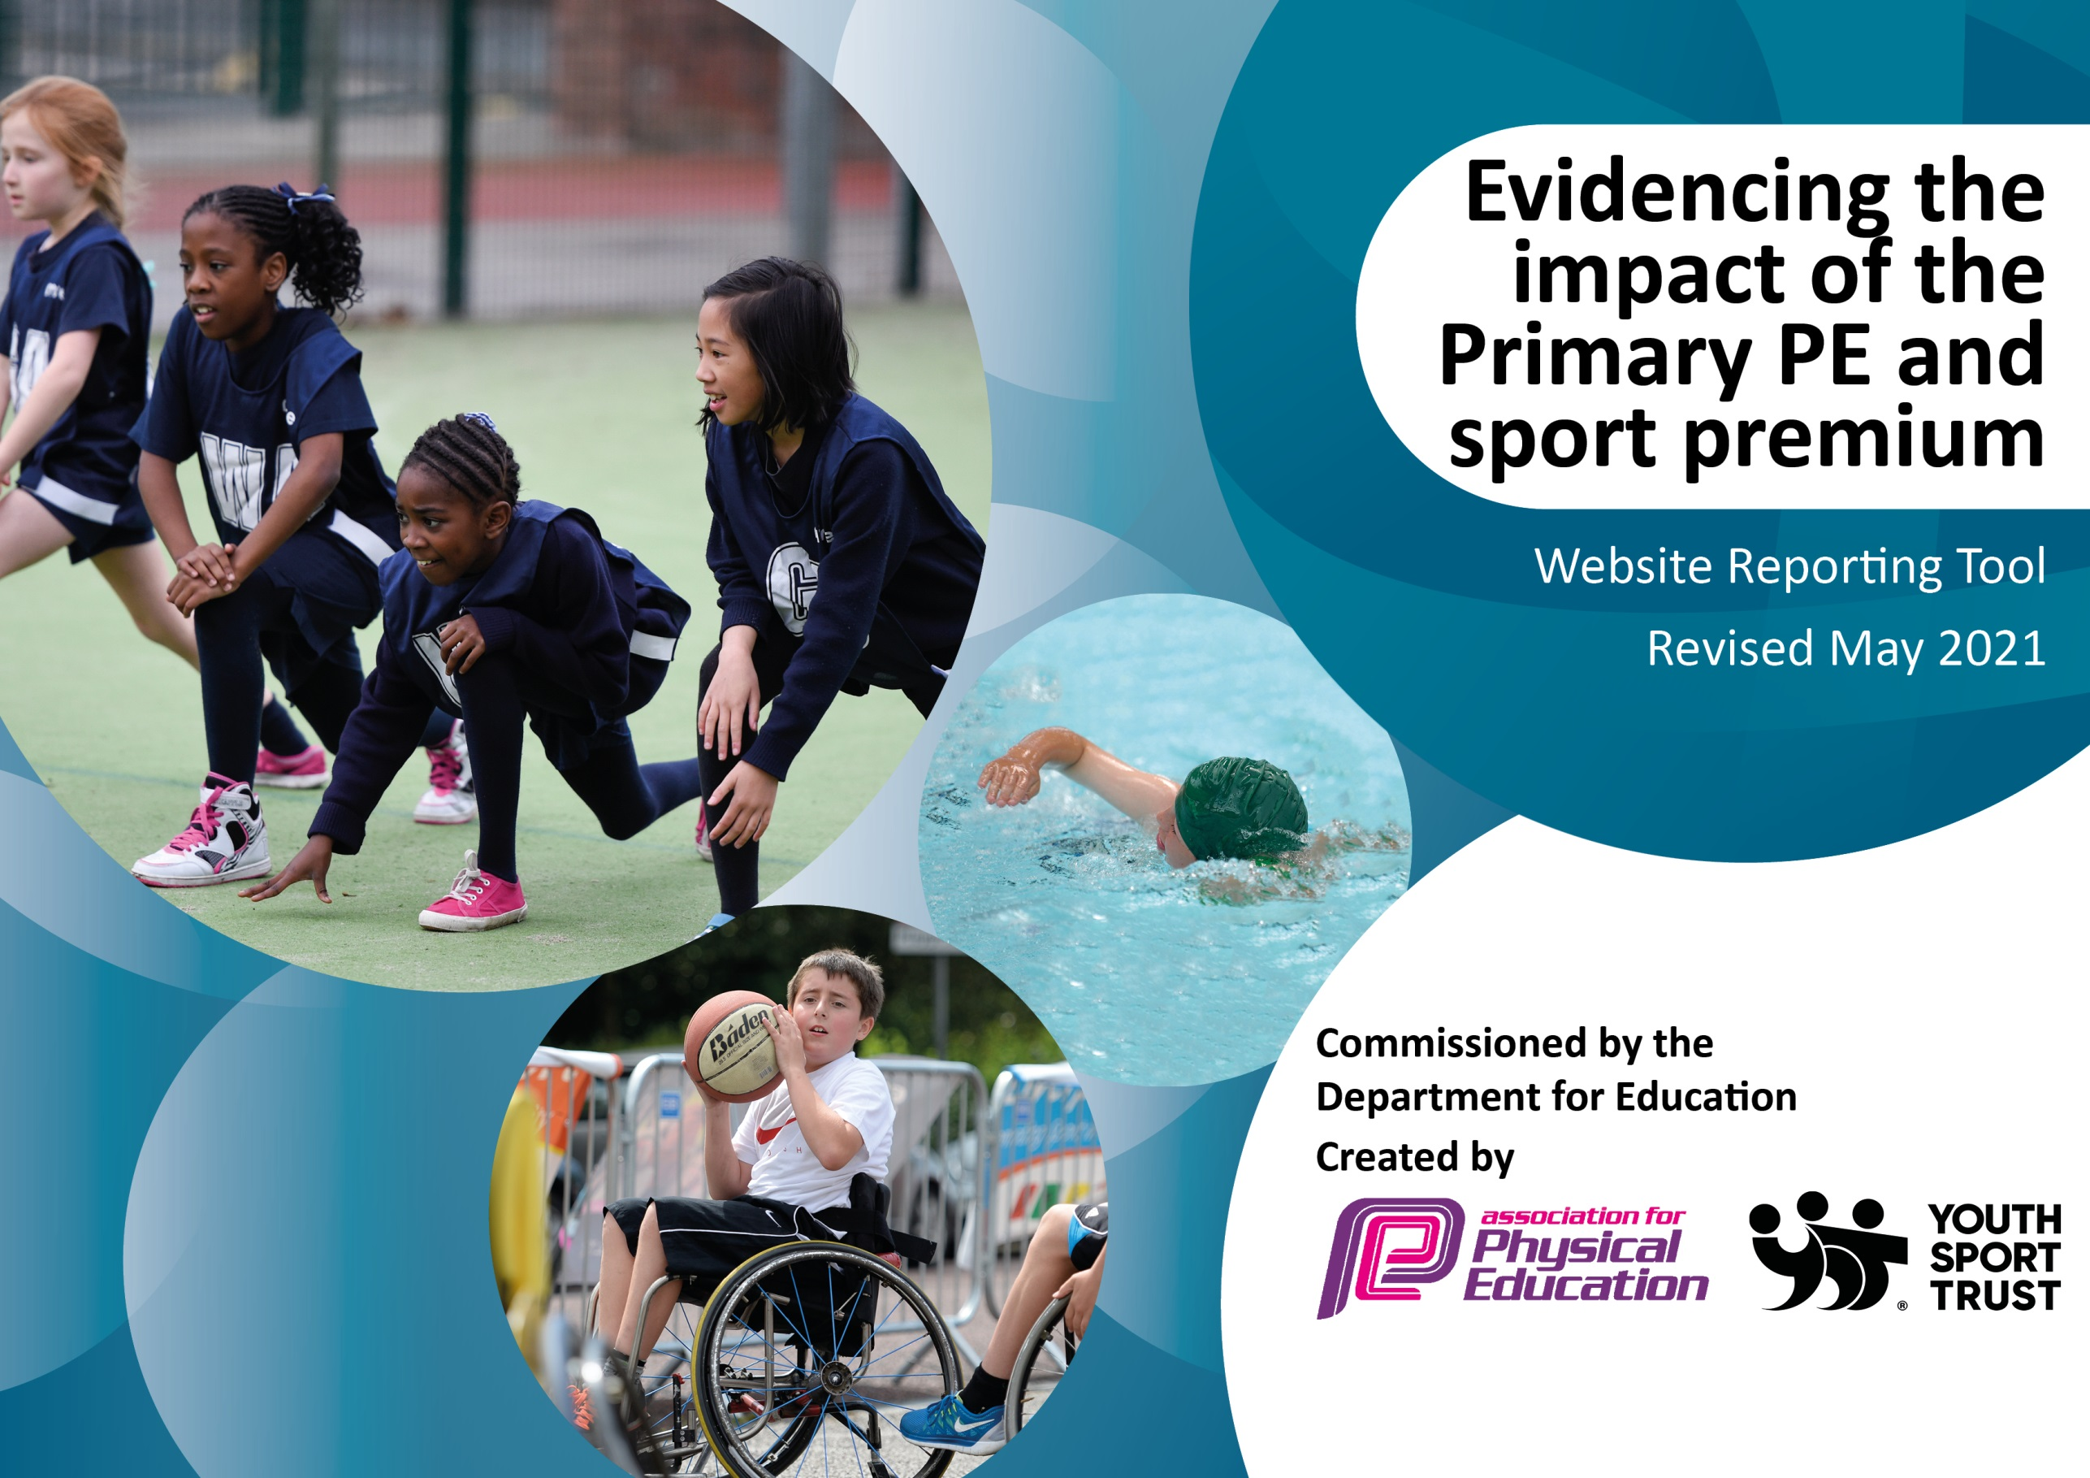

It is important that your grant is used effectively and based on school need. The Education Inspection Framework (Ofsted 2019 p64) makes clear there will be a focus on ‘whether leaders and those responsible for governors all understand their respective roles and perform these in a way that enhances the effectiveness of the school’.

Under the Quality of Education criteria (p41) inspectors consider the extent to which schools can articulate their curriculum (INTENT), construct their curriculum (IMPLEMENTATION) and demonstrate the outcomes which result (IMPACT).

To assist schools with common transferable language this template has been developed to utilise the same three headings which should make your plans easily transferable between working documents.

Schools must use the funding to make additional and sustainable improvements to the quality of Physical Education, School Sport and Physical Activity (PESSPA) they offer. This means that you should use the Primary PE and sport premium to:

- Develop or add to the PESSPA activities that your school already offer
- Build capacity and capability within the school to ensure that improvements made now will benefit pupils joining the school in future years
- The Primary PE and sport premium should not be used to fund capital spend projects; the school’s budget should fund these.
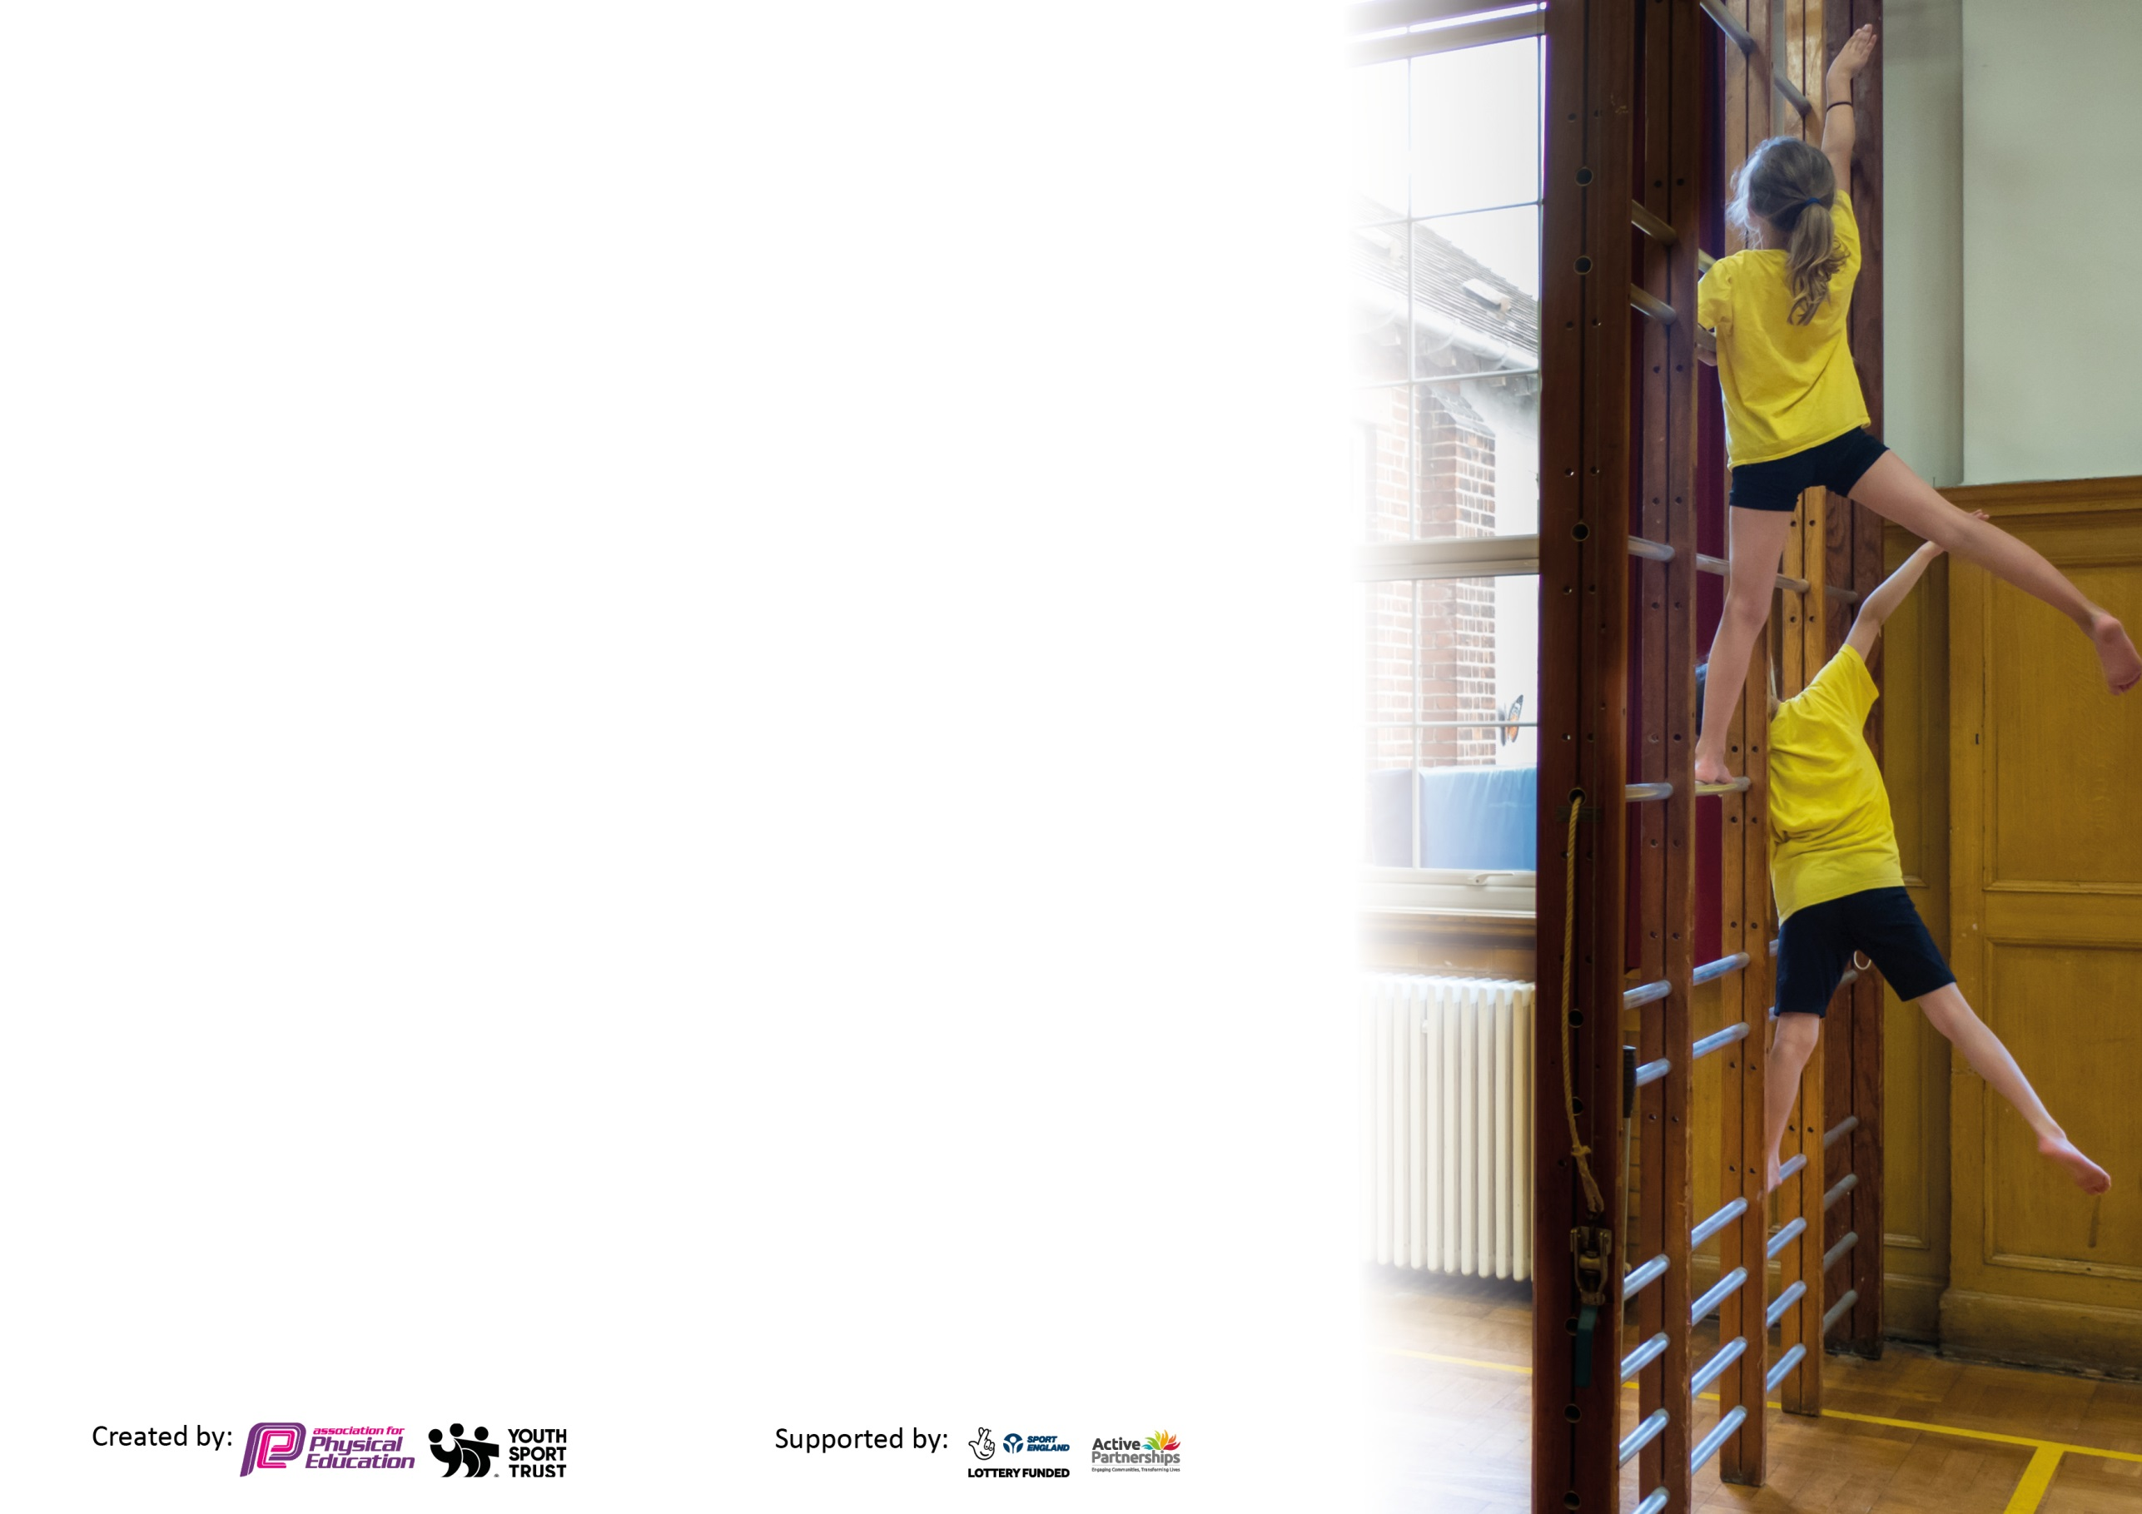
Please visit gov.uk for the revised DfE guidance including the 5 key indicators across which schools should demonstrate an improvement. This document will help you to review your provision and to report your spend. DfE encourages schools to use this template as an effective way of meeting the reporting requirements of the Primary PE and sport premium.

We recommend you start by reflecting on the impact of current provision and reviewing the previous spend.

Schools are required to publish details of how they spend this funding, including any under-spend from 2019/2020, as well as on the impact it has on pupils’ PE and sport participation and attainment by the end of the summer term or by 31st July 2021 at the latest.

We recommend regularly updating the table and publishing it on your website throughout the year. This evidences your ongoing self-evaluation of how you are using the funding to secure maximum, sustainable impact. Final copy must be posted on your website by the end of the academic year and no later than the 31st July 2021. To see an example of how to complete the table please click HERE.

Please note: Although there has been considerable disruption in 2020 it is important that you publish details on your website of how you spend the funding - this is a legal requirement.
Support for review and reflection - considering the 5 key indicators from DfE, what development needs are a priority for your setting and your pupils now and why? Use the space below to reflect on previous spend and key achievements and areas for development.

N.B. In this section you should refer to any adjustments you might have made due to Covid-19 and how these will influence further improvement.
Key achievements to date until July 2020: | Areas for further improvement and baseline evidence of need:
Bronze School Games Award  Sports Day annually held at a professional athletics venue  CPD for teachers- staff identified the area they would like more support in  Teachers teaching PE for 2 hours per week  Children in Year 5 attended Swimming until lockdown. They then received one free month of swimming with providers.  Physical activities sent home for children completing home learning  Lunchtime leaders trained by DRFC  KIXX led weekly competitions during lunchtime | - To meet higher targets on swimming  . * focusing on the safe, self- rescue due to sessions being interrupted.  - To Promote higher activity levels through the day, even during Covid limitations  - Continue to ensure all children are physically active every time they have outdoor time. Introduce playground zones to ensure ‘bubbles’ have adequate space and equipment to be active.  - To build staff confidence and capability to deliver a high quality curriculum  CPD for staff using new scheme.  - To embed pupil voice to ensure active lifestyles are encouraged through play and provision. Pupil Voice to be launched in the Autumn Term- they will complete an audit with their peers to highlight the strengths and weaknesses of not only PE lessons but also playtimes and lunchtimes. This will ensure we are giving the pupils a voice to enhance and promote active lives.  - All ‘bubbles’ to receive a pack of equipment for PE lessons and outdoor time to ensure children are physical active and having fun, as well as supporting infection control.  - To ensure the curriculum is rewarded through achieving the Silver School Games Mark

Did you carry forward an underspend from 2019-20 academic year into the current academic year? YES Delete as applicable
Total amount carried forward from 2019/2020 £ 1438.92
+ Total amount for this academic year 2020/2021 £20,000
= Total to be spent by 31st July 2021 £21,438.92
Meeting national curriculum requirements for swimming and water safety.  N.B Complete this section to your best ability. For example you might have practised safe self-rescue techniques on dry land which you can transfer to the pool when school swimming restarts.  Due to exceptional circumstances priority should be given to ensuring that pupils can perform safe self rescue even  if they do not fully meet the first two requirements of the NC programme of study. | Due to Covid restrictions, the focus for swimming sessions was safe, self-rescue.
What percentage of your current Year 6 cohort swim competently, confidently and proficiently over a distance of at least 25 metres?  N.B. Even though your pupils may swim in another year please report on their attainment on leaving primary school at the end of the summer term 2021.  Please see note above. | 32%
What percentage of your current Year 6 cohort use a range of strokes effectively [for example, front crawl, backstroke and breaststroke]?  Please see note above. | Due to Covid restrictions, the focus for swimming sessions was safe, self-rescue.
What percentage of your current Year 6 cohort perform safe self-rescue in different water-based situations? | 90%
Schools can choose to use the Primary PE and sport premium to provide additional provision for swimming but this must be for activity over and above the national curriculum requirements. Have you used it in this way? | Yes/No
*Children who did not complete the swimming sessions in Year 5 have been given vouchers to access sessions.
Action Plan and Budget Tracking
Capture your intended annual spend against the 5 key indicators. Clarify the success criteria and evidence of impact that you intend to measure to evaluate for pupils today and for the future.
This document is part of the school Developing Excellence Plan routed in research based practise (John Hattie, Tom Sherington, Barry Carpenter, John Tomset, Johnny Utley, Oliver Cagioli) to positively influence staff development to reconnect and reignite our children with PE.

Academic Year: 2020/21 | Total fund allocated: £ | Date Updated:
Key indicator 1: The engagement of all pupils in regular physical activity – Chief Medical Officers guidelines recommend that primary school pupils undertake at least 30 minutes of physical activity a day in school |  |  |  | Percentage of total allocation:
 |  |  |  | %
Intent | Implementation |  | Impact
Your school focus should be clear what you want the pupils to know and be able to do and about  what they need to learn and to  consolidate through practice: | Make sure your actions to achieve are linked to your intentions: | Funding allocated: | Evidence of impact: what do pupils now know and what can they now do? What has changed?: | Sustainability and suggested next steps:
To ensure children reconnect with being physically active at playtimes and lunchtimes. | - To develop the outside areas ensuring the pupils voice is heard to showcase their interests and skills.  - To have ‘zones’ in the outside area with new and engaging equipment linked to them.  Zones- football, race track, ball skills-netball, 4throw, basketball, climbing wall, table tennis, hoops, skipping ropes, dance, bats and balls.  - Pupil voice to complete an audit of lunchtimes with feedback creating plans for the next term. | £3000-  equipment bubble boxes  Table Tennis- £1498 | Pupil Voice: I like the zones as we do something different each day.  I wish we could play football everyday but I know it is better that I use different equipment to make me better.  Less incidents have occurred at lunchtime as children are in smaller spaces and have their own equipment. | Ensure each zone is marked out.  Audit equipment every half term and involve pupil voice with the process.  More children from bubble have access to all equipment through the timetable which exposes them to more sport/ activity.
During the lockdown period and feedback from remote learning it has been identified that there has been a significant reduction in physical activity and an increased use of gaming. This has impacted the hand-eye co-ordination. On return, PE sessions have focused on fundamental skills through multi sports to ensure skills are embedded. | - Throwing and catching skills embedded in KS1.  - Teachers following lesson plans to ensure structure and routine.  - Re-establish connections made from prior learning.  - Equipment distributed to bubbles including hula hoops, balls, bean bags etc.  - ‘Ball zones’ on the playground- 4 shot. | £3000- 4 shots | What does the data show?  Are children engaging with the designated zones of play?  Teachers- My class now set each other challenges and time/ count how many of them can catch the ball from the correct shot. Children are more active and forming different friendship groups through it. | Audit of equipment- replenishment and giving the children the ‘ownership’ of the equipment through pupil voice.
Key indicator 2: The profile of PESSPA being raised across the school as a tool for whole school improvement |  |  |  | Percentage of total allocation:
 |  |  |  | %
Intent | Implementation |  | Impact
Your school focus should be clear what you want the pupils to know and be able to do and about  what they need to learn and to  consolidate through practice: | Make sure your actions to achieve are linked to your intentions: | Funding allocated: | Evidence of impact: what do pupils now know and what can they now do? What has changed?: | Sustainability and suggested next steps:
To increase the profile of attendance in school by running a summer initiative for all children. | - Children who are awarded with 98-100% attendance will receive a summer sports pack with activities and resources to take home to encourage a physical/ active summer. | £1000 | 132 children received the initiative across the whole school. | Initiatives planned for Sept- how has it impacted on the attendance of the targeted?
Achieve Silver Award for the School Games accreditation. | - Follow the guidance to achieve silver through; entering competitions, curriculum time given to PE, whole school events such as Sports Day given a priority. |  | How has the award enhanced the competition calendar?  What skills have the children gained?  Who has participated?  The whole school took part in the Doncaster School Summer Games project.  The whole school completed the ‘race to Tokyo’, running miles and participating in cross curricular events. | This increased the profile of the Olympic Games profile.  Children took part in a whole school competition and continued our links for future projects alongside the School Games organiser.
To provide high quality PE sessions. | - Re-establish rules, expectations and routines.  - Provide instant feedback.  - Follow the Your-PE scheme.  - Ensuring a progressive curriculum throughout school.  - Promote a healthy lifestyle ‘Be the role model’ | £500- scheme | Teacher feedback- See leadership file. 12 teachers said they felt more confident teaching PE from the programme. Having videos showing the skills has provided extra CPD and knowledge for the staff.  Your-PE scheme feedback- what has worked well? What hasn’t?  Obesity figures- 2019/20  Reception-overweight 2% underweight 5%  Yr 6- 2% underweight 13% overweight 23% | Children from Year 3 and 5 (14) have been involved on 3 occasions filming skills workshops with Your-PE.  Assessment of PE to take priority in 21-22.
To develop the EYFS outdoor area due to the obesity figures- %  Children need the gross motor skills to then be secure with fine motor skills which then impacts writing (A focus across the school). Looking at the whole child to ensure their development is strong. | - Work alongside the EYFS lead to meet the needs of the children.  - Purchase equipment that not only follows the interests of the child but also focus on the Physical Development prime area. | £1300 | GLD.  Feedback of how the children are using the equipment. | GLD 59% Physical Moving and Handling  Children have physical items that build team work and other social aspects of the curriculum. Children are learning to ride a bike with confidence.
Install a track as a ‘play zone’ to create a safe space for bikes and scooters. Track to be used for children to race and be a ‘space for them to be, to re-discover and gain confidence.’ | - Use pedometers to track steps – Active Maths and bubble competitions.  - Alongside a new running track there will be a solar powered timer so children can time each other and set personal bests.  - Timetable equipment for bubbles ensuring Covid guidance followed. | £3000  Solar panel stop watch, track | Children in their bubbles competing against peers and setting PB’s.  Stop watch also used during Clancy Briggs cycling sessions. | Whole school comp- who can run the fastest 100m?
To increase the Cultural Capital of all children by attending the annual sports day at a professional athletics track. | - Children put into teams for competitive element  - Children to use skills and knowledge from PE sessions.  - Celebrate the success of the day through blogs.  - Links to increased participation in competitive sports. | £1280- buses  Fee- £150  Water- £50  Trophy/ medals/ stickers - £100  Photocopying of plans for all staff- £40 | The whole school participated in a ‘Sports Event’ planned on different days following covid risk assessment.  Parents unable to attend due to government restrictions.  Many children wrote about the experience in their school report- ‘I loved racing around the track’ ‘The long jump was amazing, I used the measurement to compare my peers jump’  340 children attended sports day at a the ‘Doncaster Athletics Track’ | Bookings made for 2022- EYFS to join for half a day.

Key indicator 3: Increased confidence, knowledge and skills of all staff in teaching PE and sport |  |  |  | Percentage of total allocation:
 |  |  |  | %
Intent | Implementation |  | Impact
Your school focus should be clear | Make sure your actions to | Funding | Evidence of impact: what do | Sustainability and suggested
what you want the pupils to know | achieve are linked to your | allocated: | pupils now know and what | next steps:
and be able to do and about | intentions: |  | can they now do? What has
what they need to learn and to |  |  | changed?:
consolidate through practice:
To provide professional development across PE with teachers working together as evaluators of their impact in PE. | - Staff CPD audit to find out what teachers feel they need and want in terms of CPD- continuation of staff voice from previous year. Autumn term audit completed by JH using Microsoft Forms.  - Drop in of P.E. lessons by coordinator and feedback to teacher.  - Monitoring of assessment. Support for teachers when assessing if necessary through the use of Your-PE tool.  - PE scrutiny to monitor notes, feedback and evidence on the PE SoW app and Implementation plan. | £200 to cover PE lead to complete drop ins and team teach. | What professional development has been completed?  Implementation Plan  AFPE updates  YST PE and wellbeing conference
To ensure the PE lead is held accountable and keeping upto date with not only Covid guidelines but current research and best practise. | - AfPE support  - Community links- Active Fusion, School Games, KIXX.  - Twitter- following relevant organisations to ensure current and relevant information is on hand. | £50 | Support and challenge from governors  Implementation Plan  Subject Knowledge
To adapt to teaching PE safely during the Covid 19 pandemic, but in ways that deliver the curriculum in full. | - All staff to have read new risk assessment for PE.  - Each ‘bubble’ to have their own bag of equipment to be used in lessons and as part of active playtimes. Any extra equipment they need from the PE store will be kept for the half term.  - Children and staff will come to school in their PE kit.  - Plans may need to be adapted to fit in with social distancing and infection control. |  | Risk assessment evidence  Following current research from AfPE  How many children are coming to school in their PE kit? Has this increased from last year?  All staff informed of any changes through weekly staff briefing.  80% of children coming to school in their kit. Increase of 40% previous years when children got changed in school. | Continue to allow children and staff to attend school in their kit on their PE day. Target- 100%  Target children/ classes with low intake of children coming in kit.  Target ALL to ensure correct kit is worn in line with uniform policy.
To upskill the lunchtime supervisors by providing training sharing the vision of healthy lifestyles school wide. | - Children access equipment using skills from prior learning.  - Lunchtime supervisors choose activities, following the children’s interests  - Provide ‘Active Cards’ for staff to follow. | £150 to cover PE lead | How many children are actively engaged with lunchtime supervisors?  Lunchtime supervisor feedback.
Lessons enhanced using the correct equipment. | - Key stage bags of equipment linking to lesson plans- progressive.  - Audit of equipment. | £1000 | Audit of equipment carried out in Summer 1. Teachers responded with what could make the sessions better in regards to equipment e.g. more cricket equipment to upskill. | Pupil voice to complete audits?  Your-PE purchased for next year to continue with the same scheme and equipment. Consistency for staff and children.
To ensure a minimum of 2 hours of PE is taught every week. | - PE timetabled for every year group from EYFS- 6.  - PE lead to monitor timetables.  - Support and training for staff. | £0 | Curriculum coverage.  Has delivering more PE impacted on data and obesity figures? | Check obesity figures when released by Public Health.  Ensure curriculum coverage through Your-PE map.
Key indicator 4: Broader experience of a range of sports and activities offered to all pupils |  |  |  | Percentage of total allocation:
 |  |  |  | %
Intent | Implementation |  | Impact
Your school focus should be clear | Make sure your actions to | Funding | Evidence of impact: what do | Sustainability and suggested
what you want the pupils to know | achieve are linked to your | allocated: | pupils now know and what | next steps:
and be able to do and about | intentions: |  | can they now do? What has
what they need to learn and to |  |  | changed?:
consolidate through practice:
To remove educational inequality and provide opportunities to succeed outside of the school day with a focus on exploration.  To promote mental health and wellbeing of pupils and families enabling them to positively contribute to society. | - Target and work with families to ensure increased participation and attendance.  - Track attendance of all clubs.  - Link with the school community- different business promoted via social media. | £1000- Summer 2 clubs | What opportunities have been provided?  Comparison of data from previous years.  Views from parents and children.  Clancy Briggs- 4 children in Year 4 learnt to ride a bike  ACMAC- self-defence in a safe environment using the correct technique  Summer Sports YR 1,2,5,6. | Clancy Briggs and ACMAC After school clubs- Summer 2- new community links for school.
Re-establish routines and relationships through socially distant Intra-school. | - Year group bubble competitions every half term.  - Celebrate successes on social media and class blogs. | £200 | Pupil voice  ‘Bubble’ competitions- Table Tennis, Fastest 100m, fitness.  Positive parental feedback. | Competitive element-PB’s?  End of each half term for all children to take part in an element of peer competition
Ensure there is adequate planning for remote learning to ensure children stay active in the event of another closure. | - Have planned activities such as; Joe Wicks PE, virtual activities, focus on skills using everyday objects- throwing, catching, targets.  - Use social media to engage parents and children. |  | Was the remote learning needed? PE sessions planned into weekly home learning.  Who for- 9/12 home learning packs/ online remote learning used in Summer 2.  How do we know it was Completed-Feedback and check in from CT and KA. Safeguarding checks. | If remote learning is still needed in Sept, children to be signposted to the Your-PE website. Sessions to also be on the paper home learning packs in 1 of the 5 curriculum sessions covered.
To engage children removing educational inequality and provide opportunities to success and engage through the Rugby World Cup Legacy Project. | - Children given country to host and learn about.  - Opportunities to attend matches.  - CPD for Staff- Tag Rugby - postponed (Covid)  - Tag Rugby festival- year 4/5 - postponed (Covid)  - Player visit- inspiring children to get involved  - Coaching sessions from Doncaster RLFC |  | How many children participated?  YR 4 and 5 (120 children) participated in a workshop led by DLFC alongside professional rugby player Watson Boas.  Children commented on this in their school report- ‘Best day ever meeting a professional rugby player!’  ‘I learnt about moving the ball using the correct techniques during tag rugby.’  BCPA will represent France- Personal video message from players to school  . | Continue involvement with the competition.  Follow covid guidelines to engage as many children as possible with the ‘local’ games.
To engage children removing educational inequality and provide opportunities to success and engage through working alongside JR Sports Stars and Peglers (local manufacturing company) | - Children given the opportunity to meet England Rugby Star Jason Robinson  - Player meet and greet  - CPD for staff |  | Weekly, Year 3 participated in multi skills sessions- 60 children.  Teachers also took part as CPD- Invaluable CPD especially for warm up ideas and correct terminology/ vocab.  Jason Robinson school visit- JR spoke about his journey He inspired and encouraged children to talk about their worries and set a goal for his session. | Use equipment to replenish equipment boxes for each year group.  Display England shirt in school to remind children of the event and significant person they have met.
To increase the …. Of ballet for all by working alongside Northern Ballet for the 3rd year as part of their ‘Spotted’ programme. | - Children in year 3 and 4 have the opportunity to take part in a ballet workshop led by a professional ballet teacher from the academy. |  | 120 took part in the workshops  12 children were spotted.  4 children went to the ‘Spotted workshop’.  1 children selected to continue training in Sept 21. | Continue programme partnership next year with possible after school club led by professional dancer.  Track children who were spotted in their Northern Ballet Journey.  How can we get more children to attend the session?

Key indicator 5: Increased participation in competitive sport |  |  |  | Percentage of total allocation:
 |  |  |  | %
Intent | Implementation |  | Impact
Your school focus should be clear | Make sure your actions to | Funding | Evidence of impact: what do | Sustainability and suggested
what you want the pupils to know | achieve are linked to your | allocated: | pupils now know and what | next steps:
and be able to do and about | intentions: |  | can they now do? What has
what they need to learn and to |  |  | changed?:
consolidate through practice:
To provide opportunities to all our children to take part in intra and inter competition. | - Children become competitive and develop sportsman ship. | £1000 | Table Tennis Spring 2  Football- zone days  Sports Day prep in teams- Summer 2  Basketball shot- KS1 – Summer 1  Active Mile- Summer 1 whole school | Community and school games events.
To hold our annual Sports Day competition at the Doncaster Athletics Track allowing children to be inspired by using a professional venue to showcase their skills. | - Children implement the skills they have learnt in PE into competitive races and activities. | See key indicator 2 | 320 children took part  Children’s views-  I loved sports day and racing against my friends.  Sports Day was my favourite day- we did PE all day! | Booked for next year for children to progress their skills and create the excitement of an annual event.

Signed off by
Head Teacher: | E. Cooke
Date: | 14.10.21
Subject Leader: | J. Hodgson
Date: | 13.10.21
Governor: | H. Freeman
Date: | 15.10.21

